Cales Investments, Inc.
Member NASD / Member SIPC
October 31, 2005

Bernanke and the Toughest Job He Ever Loved

Ben Shalom Bernanke (born December 13, 1953), American macroeconomist, is the Chairman of the U.S. President's Council of Economic Advisers and the nominee to succeed Alan Greenspan as Chairman of the Board of Governors of the United States Federal Reserve (Fed). He was previously a member of the Board of Governors of the Federal Reserve, serving from August 2002 until just prior to his June 2005 swearing-in as chairman of the Council of Economic Advisors. Bernanke was previously the chairman of the Department of Economics at Princeton University. On October 24, 2005, President Bush nominated Bernanke to succeed Alan Greenspan as Chairman of the Federal Reserve. Greenspan will retire on January 31, 2006 after 18 years as chairman. In March 2005, a few months prior to becoming Chairman of the CEA, he gave a speech which argued that a "global saving glut," resulting from new patterns in international capital flows, was largely responsible for the American current account deficit. This was controversial among those economists who felt the trade deficit was due instead to excessive governmental spending. If confirmed by the U.S. Senate, Bernanke would lead the world’s mightiest economy starting January 31, 2006. Mr. Bernanke can not afford to change Fed policy overnight, should he contemplate any changes at all. The Fed Governors have to build a consensus Greenspan was a masterful consensus builder. So far, we know that Bernanke differs from Greenspan in that he would like to target specific inflation rates, whereas Greenspan preferred a more flexible approach to achieve the Fed’s dual mandate of keeping inflation low and economic growth sustainable. The rate of acceptable inflation has long been thought to lie between 1% and 2%. Bernanke is not going to change that in the immediate future.
The situation Mr. Bernanke is inheriting from Mr. Greenspan is precarious but not necessarily desperate.
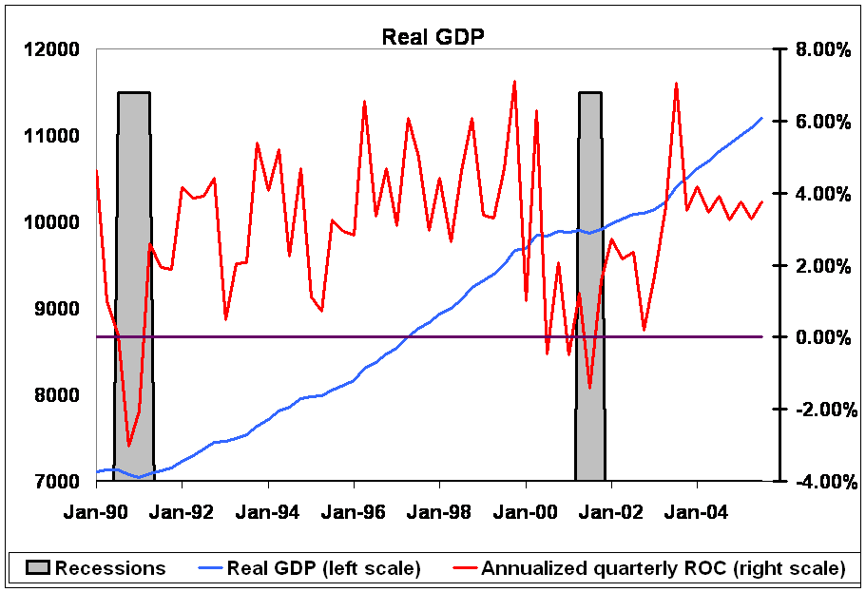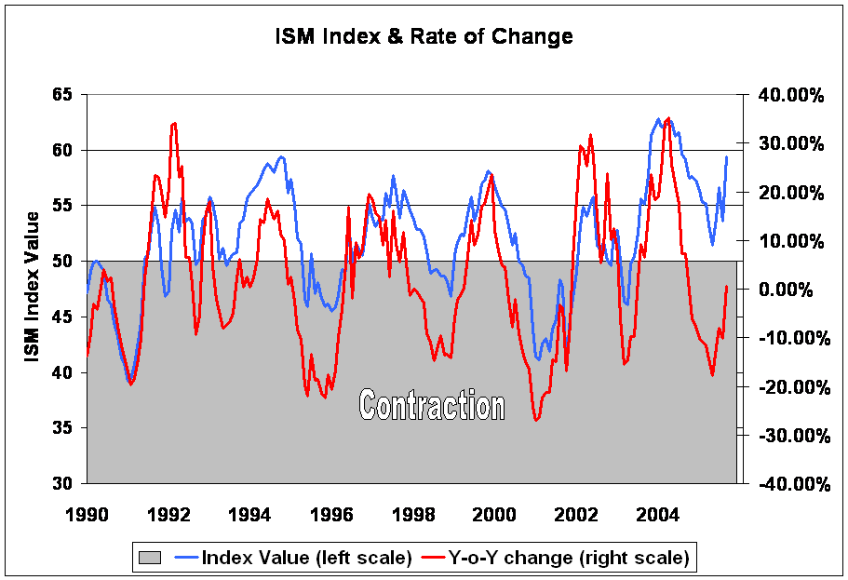
The first estimate of 3rd quarter GDP was released on Friday (Chart top left). The U.S. Commerce Department reported that the economy grew at a 3.8% quarter to quarter seasonally adjusted annual rate. The median market forecast was for a 3.6% growth rate, and the difference between that and the reported figure is not statistically significant. Solid growth in the quarter, which is mostly based on pre-hurricane data, suggests that Greenspan’s (Bernanke’s) Federal Open-Market Committee will be feeling more comfortable with the view that the economy's underpinnings are healthy enough to withstand the energy price shock and therefore that monetary tightening can continue apace. So far so good. The chart above on the right shows the Institute for Supply Management (ISM) Index. It was formerly called the Purchasing Managers Index and is designed to give a first hand report from the front line of the manufacturing sector. The report for September reads: "The manufacturing sector grew for the 28th consecutive month in September based on the ISM data. The index made a strong move to the upside as New Orders and Production rose significantly. This move was supported by slower deliveries and growing order backlogs. While energy prices and the impact from Hurricane Katrina are major concerns, the manufacturing sector has regained significant momentum."
The October report will be published on Tuesday and hopefully continues in the same direction post-Katrina.

The trickier part for Mr. Bernanke will be the fallout from a slowing housing sector. Not only is there slippage in prices and even sales are threatening to fall off, but, as David Rosenberg of Merrill Lynch reports, the inventory of newly-built homes that haven't been sold is up a whopping 20% over last year, the biggest such increase in more than two decades. In addition, Barron’s quoted Stephanie Pompoy this week, “Among other things, she points out, $1 trillion in adjustable-rate mortgages are slated to reset in the next 18 months and no less than half of these will hit sub-prime borrowers. That's destined to take a toll, not only on the lenders, but on the poor souls who can't cough up the extra dough and on discretionary spending generally.” This will give Mr. Bernanke sleepless nights for sure. Just picture the situation, the new Fed Chairman is faced with: Inflation is threatening to exceed the Fed’s upper target and GDP growth, though still robust, is expected to slow in the coming quarters to 2% or less. In other words, rising inflation, a slowing economy and an exhausted consumer all conspire to make his life miserable right from the start.
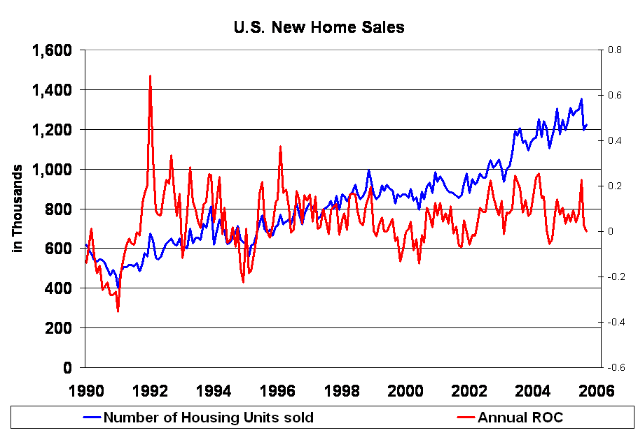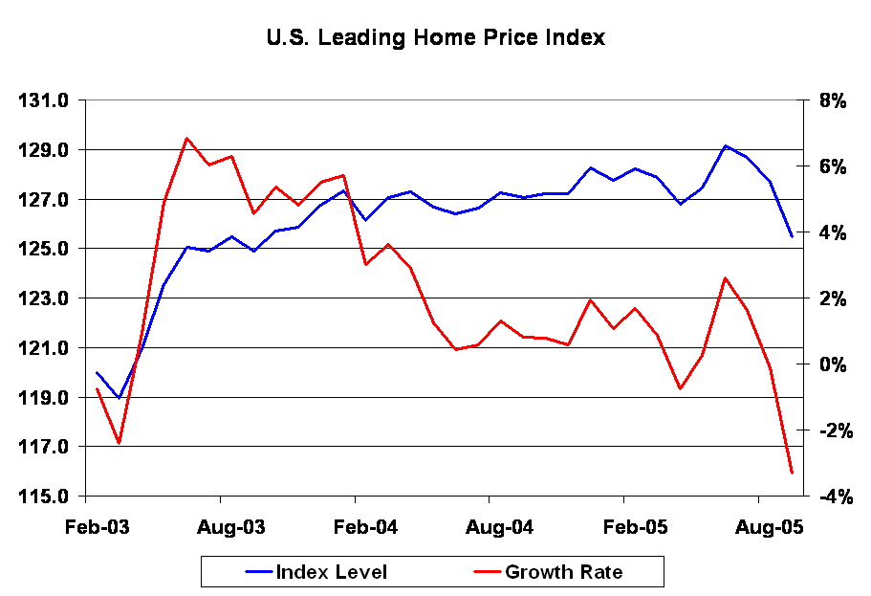
The chart on the left shows existing home sales through the month of September. Sales of new one-family houses in September 2005 were at a seasonally adjusted annual rate of 1,222,000 according to estimates released jointly today by the U.S. Census Bureau and the Department of Housing and Urban Development. This is 2.1 percent above the revised August rate of 1,197,000, but is 0.1 percent below the September 2004 estimate of 1,223,000. Homes are still selling, yes. But as the red line (the Annual Rate of Change) indicates, the numbers are stagnating.
The chart on the right shows the Economic Cycle Research Institute’s (ECRI) U.S. Leading Home Price Index. This index is designed to lead cyclical swings in real (i.e., inflation-adjusted) median home prices. “It is a summary measure of the best leading indicators of U.S. home prices” according to the Institute. The estimated lead time at peaks and troughs is ten months.
Mr. Bernanke stated that there is no housing bubble, even though Mr. Greenspan detected some froth in certain areas. No matter what you call it, the number of housing units sold has been falling and the inventory of unsold homes has been rising. The average price paid for a single family home is dropping and mortgage rates continue to rise, which will make the average home less affordable. This also means that “cash out” refinancing will become more and more difficult.

Bill Gross wrote in his latest newsletter: “We are due for what appears to be a 2% or less GDP growth rate in 2006, a rate sure to stop the Fed and to induce eventual easing at some point later in the year. It will likely be Bernanke’s first policy shift and an indicator of his willingness to address the Fed’s dual mandate of inflation targeting and economic growth.”

Given all these circumstances, we can only wish Mr. Bernanke good luck. He is not inheriting an easy task.

Hermann Vohs

