Cales Investments, Inc.
Member NASD / Member SIPC
November 30, 2005

Supply and Demand in the Labor Market

The November rally stalled last week. Earlier in the week, much stronger-than-expected reports on new-home sales and durable goods, and an upward revision of the third-quarter GDP were key in convincing the market that the Fed may have to raise interest rates more than previously assumed. As a result bonds fell and 10-year yields rose from 4.43% last week to 4.52%. The market fully assumes that the Fed will lift rates by another quarter-point on Dec. 13, and sees a 92% chance that it will again raise rates on Jan. 31, bringing Fed funds to 4.50%. But this week, the market has begun to price in much more aggressively the chance of another rate hike at the Fed's March 28 meeting. While the market was last week pricing in a 32% chance of such a hike, which would lift Fed funds to 4.75%, the odds moved to 56% by Thursday and to 68% by Friday, according to Miller Tabak.
Further confirmation that the Fed and it’s new Chairman Bernanke might raise rates further than expected (and possibly overdo it) came Friday, when the November employment report was released. A rise in payroll employment of 215,000 and an unchanged unemployment rate of 5% confirmed the established trends of the last two years: Employment increases that are fairly modest by the standards of the late-1990s have been enough to lower the unemployment rate by nearly half a percentage point per year. If these trends persist through 2006, the labor markets will get increasingly tight as the rate of joblessness moves into the 4% region.
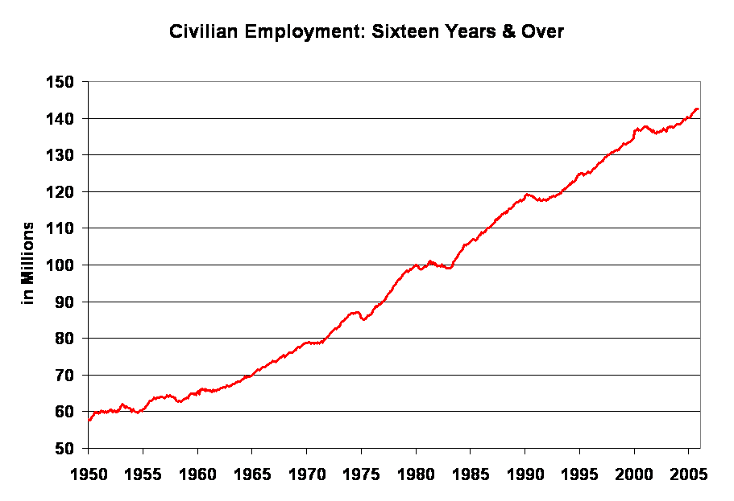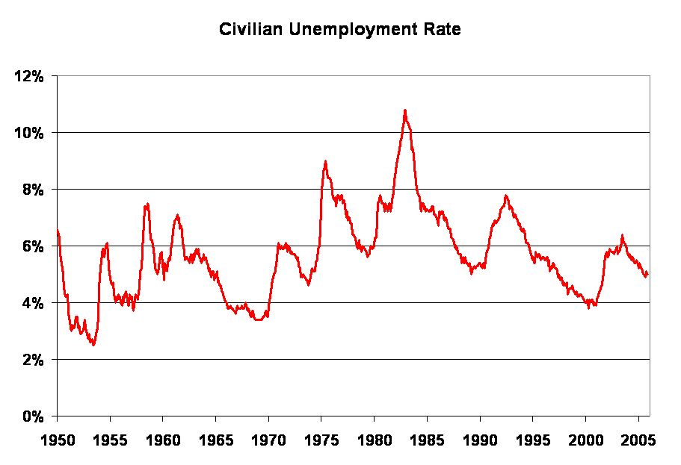
Why are people complaining that this country is losing valuable manufacturing jobs to India and China when the unemployment rate is the fifth lowest in the industrialized world? Lower are Japan, Australia, Austria, Ireland.
Gene Epstein at Barron’s writes: “The broad story is that a greater share of "transportable" service work definitely has lost out to foreign competition. Apart from engineering, however, the main effect of "off-shoring" has been to cap the growth of these professions, not cause outright declines. White-collar employment in general has accounted for an increasing share of total employment. The main casualty of foreign competition has been, as always, factory work.” Nevertheless, as the top left chart demonstrates, there are now more people working in the US than at any time before. It is true that in the last 30 years the percentage of blue collar workers has collapsed. Whereas in 1969 close to 40% of the American workforce consisted of blue collar workers, the percentage today has dropped below 25%. While the loss of these often well paying jobs is a personal tragedy, it may not be as bad as some politicians or union representatives make it out to be. Barron’s Gene Epstein writes this week: “Let's look at the numbers as they stood in the third quarter of 2005, the most recent period for which data are available, compared with a fairly tough base period -- 2000, the peak year of the previous boom, when the unemployment rate was at a 30-year low. For example, if management jobs are supposed to be in peril, you wouldn't know it from the figures. With a total of 20.5 million folks currently employed as managers in the U.S., this category of employment has added nearly a million jobs since 2000. Then, as now, about one out of seven jobs in the U.S. is classified as managerial. The professions, which exclude managerial jobs, did even better -- although here there is evidence that transportable services lost out to foreign labor. At 28.5 million, professions as a whole gained 1.8 million since 2000. Not surprisingly, the biggest gainer was health care, which added 1 million, to 6.9 million. … At 9.2 million, factory jobs fell by 2.2 million since the year 2000. While it's hard to sort out how much of it was due to rising productivity, foreign competition was probably the main factor involved.”
While it is true that manufacturing jobs have been moved (purposefully (!) by US corporations) overseas, it seems that the overall standard of living in this country has not suffered much. Real disposable income grew on average by 3% per year since 1959, whereas the average workweek declined from 38 hours in 1964 to around 34 hours today. The US economy is doing well and the average employee is participating, even though he might not stand in a factory wearing a hart-hat, hammering away at a piece of metal. Heavy industry or the manufacturing sector in general is no longer the symbol of industrial might. The hard line communists in Moscow were the last ones to believe that. I am sure that even Chinese companies are lamenting their razor thin margins in manufacturing these days. No, what counts today is how much profit a particular sector is able to generate for the economy.
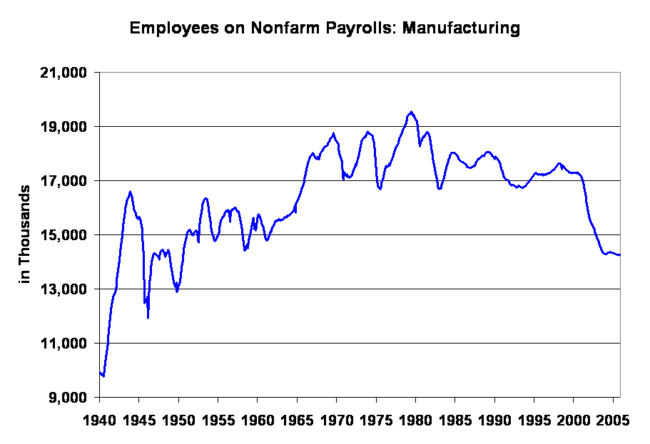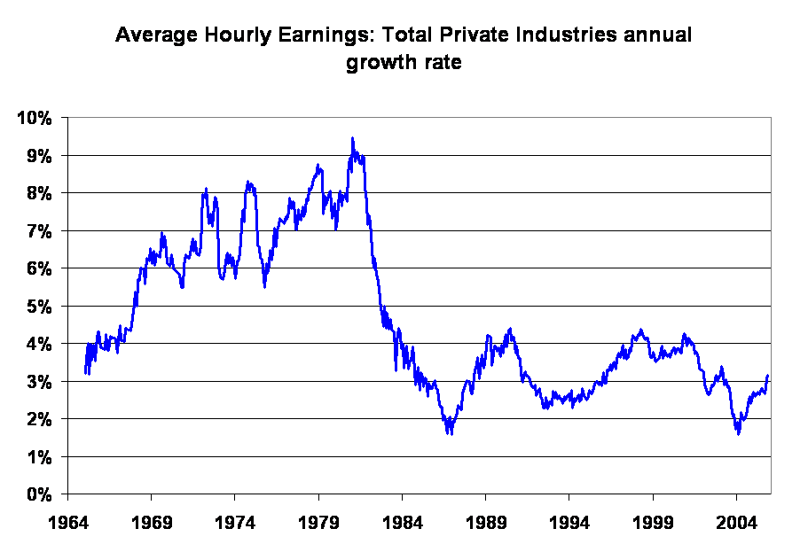
The profitability of a particular enterprise determines, how much growth can be expected and how many employees it takes to achieve this growth. Yes, the composition of the US workforce has changed, but I do not believe that it has changed for the worse. In fact, this week’s economic news has made it clear that the U.S. is currently in the midst of a self-reinforcing phase of economic growth. This growth is evidenced by the rising trends in orders and order backlog reported for the manufacturing sector throughout the week. The manufacturing sector might not employ as many people as before, but it nevertheless has a powerful multiplication effect for job creation in other sectors. The jobs report this week really wasn't needed to get this message across: It merely reinforces it. Here is what Tony Crescenzi of Miller Tabak has to say: “With respect to the jobs report, two data points stand out. First, the diffusion index, which measures the percentage of industries that added workers, rose to its highest level since May 2004. At 62.4, it is now above its 10-year average of 51.6. This suggests very good breadth in hiring. Second, consistent with past increases in profit growth, the wage figure is beginning to trend upward. The October gain for average hourly earnings was revised upward to a 0.6% gain, matching the highest reading since July 1987. The 3.2% gain was the most since March 2003 and was above the 3.1% average of the past 15 years. The broadening of hiring and the acceleration in wage gains fits with this week's reports on rising order and backlog trends. … Companies are having difficulty filling their orders and making speedy deliveries. … Evidence of rising order backlogs and slowing deliveries reflect strain on resource utilization and a decrease in the economy's spare capacity.” To summarize what has been said so many times before in this space: The economy is firing on all cylinders, resources are being stretched, the output gap is closing and inflationary pressures are rising. The stock market might have prematurely celebrated the end of the Fed’s tightening campaign, because as things stand right now, the economy is too strong for the Fed to stop raising interest rates. Incidentally, gold traded above $500 for the first time in 18 years.

Hermann Vohs

