Cales Investments, Inc.
Member NASD / Member SIPC
May 31, 2005

Europe is in bad shape – the US is not

French voters rejected the constitution of the European Union. The Dutch are likely to reject it on Wednesday as well. Politicians seem to have moved to far ahead of their electorate. While not all countries will have a referendum, it seem clear that many voters are disenchanted. The question is “disenchanted of what?”. Some say, it’s the currency that was voted down, others claim that it is the rejection of Anglo-American capitalism. Some see this as a vote against the French government and others see it as a rejection of the bureaucracy in Brussels. There may be many explanations, and they all may have some validity. Politicians must have seen it coming, though. In mid-April European leaders tore away the Stability and Growth Pact (SGP) and dismantled any hopes of liberalization of European services (the Bolkestein reforms) in the hope of securing a "Yes" votes in the May French referendum on the European constitution. In so doing, Europe's leaders sacrificed necessary economic reforms in the hope of political gains, and they will have neither. Louis-Vincent Gave said in a letter to subscribers on April 8th: “The European construction was based on the idea that the European interest should always prevail against narrow national interest. There was even a strong effort to create a European "patriotism" (i.e: common passports, European anthem, flag etc...). But today, national interest in its ugliest format (i.e.: the need to win the next election) is raising its very ugly head.” … “Let us make no mistakes about it: we have witnessed the end of the movement which started decades ago with Monnet, Adenauer, Schuman and Gasperi. Protectionism, corporatism, cronyism are now the wave of the future in EuroLand. And the politicians who will gain success at the polls will be those who position themselves against Europe (as Chirac has done) and promise to "get the most" out of the European Commission for their domestic economy. What a step backwards!”
I agree. Sell Europe! To be honest with you, if Germany would vote on the European Constitution today, I believe that the the result would be worse. Who can blame them. The constitution is a 800 page document which was not even made available to the general public. Even it it had been easily available, who would have been able to explain it to the public in simple terms? No Eurocrat can tell me that this document was made “by the people, for the people”. The reigning cast in Brussels had their own agenda. They might have had the best interest of the European Union in mind, granted, but they sure seemed arrogant to assume, that uninformed voters would applaude a construct that has been unable to deliver on the promises of economic growth and lower unemployment.
Of course, the Euro lost in value and the Dollar gained. Meanwhile, bonds, stocks and oil continued to rally.
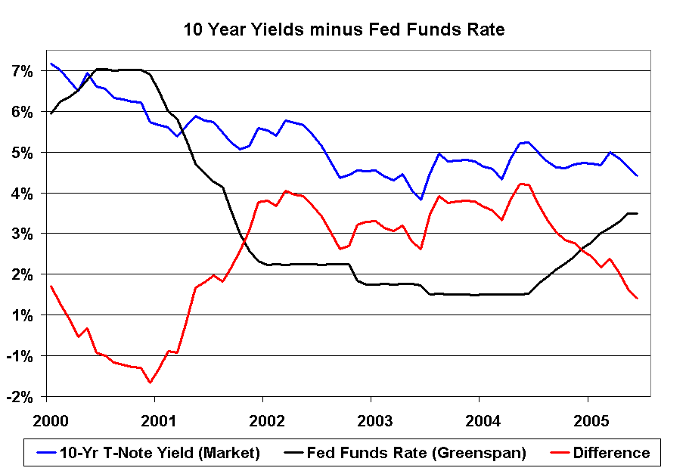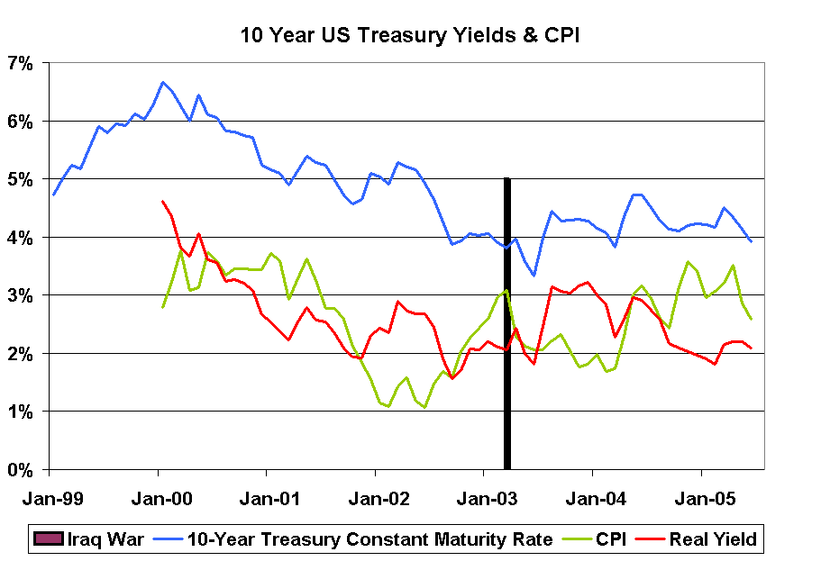

The two charts above try to illustrate the “conundrum” that Mr. Greenspan spoke about, when he referred to falling 10 year yields in the face of rising short term rates. This development is indeed counterintuitive and needs some investigation.
The left picture shows the yield relationship between short term yields and long term yields. The black line shows the overnight lending rate (Fed Funds Rate), which is controlled by Greenspan’s Federal Open Market Committee (FOMC).The blue line shows the yield on the 10 year treasury note, which moves according to the forces of supply and demand.The red line shows the difference between the two. Here now comes the conundrum. Why would somebody lend his money to the governement for 10 years at 3.92%, if the same government pays him 3% for a 90 day loan? It does not make sense, unless one assumes, that inflation is falling and competitive investment alternatives are rare. So, is inflation falling?
The right picture shows the yield on the 10 year treasury note (blue), the annual increase in the Consumer Price Index (CPI,green) as a measure of inflation and the difference, represented by the red line. We see that indeed the CPI has delined recently. The real yield (the difference between your interest and the portion that is eaten by inflation) hovers around two percent. Meager compensation compared to the year 2000, when investors were still getting 4.5%. Are we approaching a Japanese style environment, with no growth and no inflation?
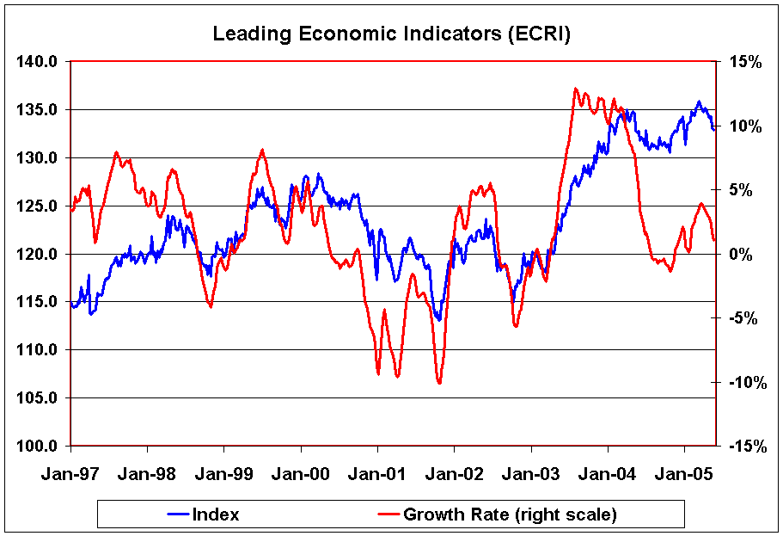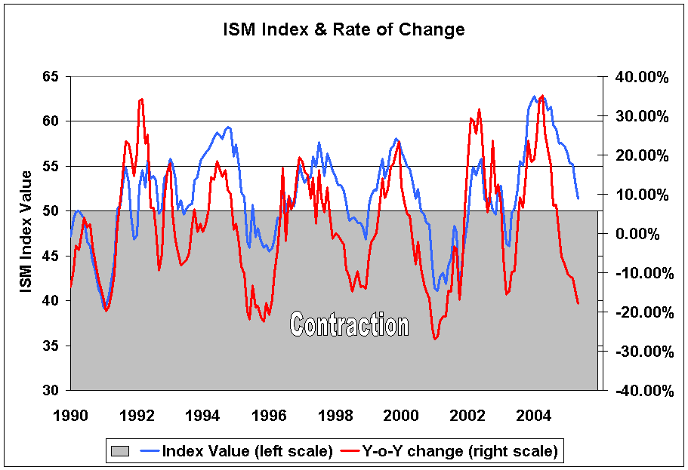
The Index of Leading Economic Indicators has been explained here many times, so I will skip the explanation today. The indicator shows that the economy is slowing. Inflation seems to be on the decline also. The ISM Index was published today and gained added significance because of Paul McCulley’s newslletter. Mr. McCulley is managing director at PIMCO, the countries largest fixed income manager. He said in his May newsletter, that the Federal Reserve always has stopped tightening, after the ISM index declined from above 50 (expansionary) to below 50. His exact words were “… the Fed, under Greenspan, has never kept tightening once the ISM Index drops below 50, as it is virtually certain to do in the months immediately ahead. Therefore, the market’s presumption (or assumption, in Governor Kohn’s lexicon) that short-term interest rates will "remain on the low side of historical averages for some time" will be validated by the data that traditionally drive Fed policy.”
There you have it. Yields have declined from 4.6% down to 3.92% in a little more than a month. This is dramatic and smells of panic. So who is panicking? Only several weeks ago, the CFTC reported that large speculators had the largest collective short position in T-Bonds ever recorded. Everybody and his uncle was betting, that T-bonds were going to decline and yields were going to rise. Obviously, the opposite happened and everybody and his uncle had to buy back their shorts. As of last Friday now, the FTCC shows the largest long position by speculators since late February. This tells me, that we are getting close to the end of this current bond rally. The economy is not as bad as the bond market makes it seem. Personal income is up 7% versus one year ago and recent consumer confidence data showed, that the consumer is resilient. Weakness in the manufacturing sector (as shown by the ISM Index) won't necessarily translate into weakness in the broader economy. Recent data even suggest, that the service sector is expanding at a better pace than in previous quarters. I think we are going to be just fine.
Hermann Vohs

e

