Cales Investments, Inc.
Member NASD / Member SIPC

November 15, 2004

Inflation everywhere

Asia greeted the re-election of George W. Bush with more enthusiasm than Europe did. Bush is perceived as an advocate of free trade and a partner in boosting regional growth. Another 4 years of the Bush administration’s promotion of globalization and free trade would benefit Asian countries the most, since they are the current vendors of choice to U.S. consumers.
In contrast, "Europeans were truly concerned because of his lack of commitment to multilateral solutions, but the Asians are looking at life from a mercantilist point of view and are concerned about access to the U.S. market," says George Hoguet, emerging-markets strategist at State Street Global Advisors. "The reality is that the Bush administration has paid much more attention to Asia as the rising economic region of the world than it has to Europe. This is appreciated by Asian leaders," wrote Chris Wood, strategist at CLSA Asia-Pacific Markets, in his weekly note to investors.
At home in the U.S., the Dow Jones Industrial Average celebrated by registering 15 higher lows in a row since the October 25 low. This was the second longest streak since 1928. It's been a difficult year so far, a year of aborted trends and lack of direction. Despite what should have been a favorable backdrop of strong earnings, low inflation and interest rates and accommodative policies on the credit, regulatory and budget fronts, there has been little to show for it but wheel-spinning. However the recent advance since mid-August has taken place on increasing volume and across an impressively broad front. What the real catalyst was is not exactly clear to me. Was it the elimination of uncertainty regarding the elections? Was it the retreat in the price of oil? Was it the signs that the labor market finally gained traction? Was it the third quarter rise in GDP? Or did all of a sudden everybody decide to buy stocks instead of commodity contracts? I don’t know. What is certain is that the speculative juices are flowing again.
Tuesday's PPI report finally offered a good excuse for profit-taking. Prices for finished goods paid by producers rose 1.7% in October, the biggest one-month increase since 1990, and 4.4% over the past 12 months. Even excluding the volatile food and energy components, so-called core PPI rose 0.3%, the same as the previous month, and 1.7% over the previous 12 months. Rising prices of commodities - especially energy-related commodities - are finally starting to creep into the "official" numbers even after all the adjustments that the bureaucrats make.
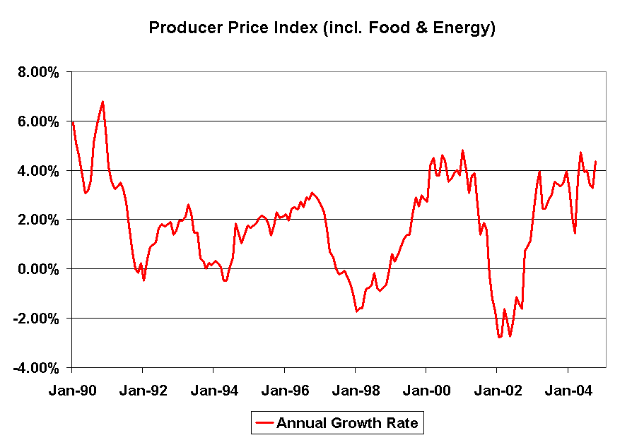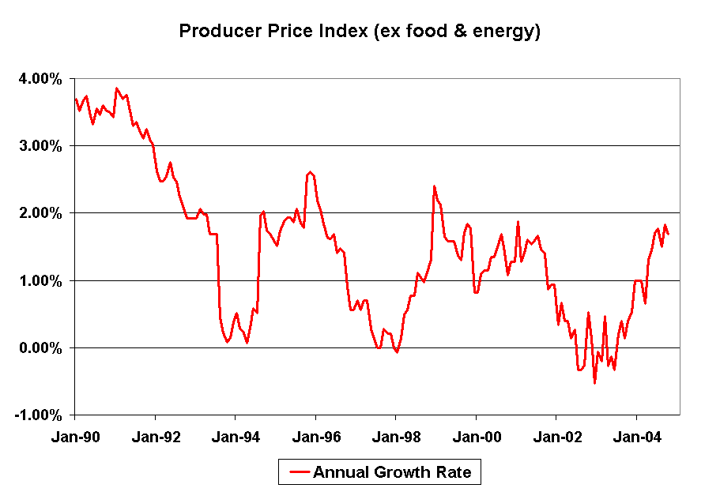

After Tuesday's October producer price index reading came in way above expectations at 1.7% -- the biggest one-month jump since 1990 -- some feared the worst for the CPI on Wednesday. They didn't get it, prompting a bond rally, of all things. Consumer prices rose 0.6% and just 0.2%, excluding the volatile food and energy components. It's more of a split decision for the economy than the slam dunk for the bond bulls. That's because it was only "core" inflation that remained low. That's the figure used by the Fed and economists to measure how much pressure on prices is likely going forward. But consumers in the "real world" have to buy food, gasoline and heating oil. They're the ones who actually saw prices go up 0.6% in October and 3.2% over the past 12 months. For the economy as a whole, these drags on the consumer are not good. Because of all the inflation over the past year, real wages are now negative over the past 12 months. That is, wages didn't keep up with rising food and energy costs. And that means consumers may be spending less over the coming months, at least once they hit their credit card limits.

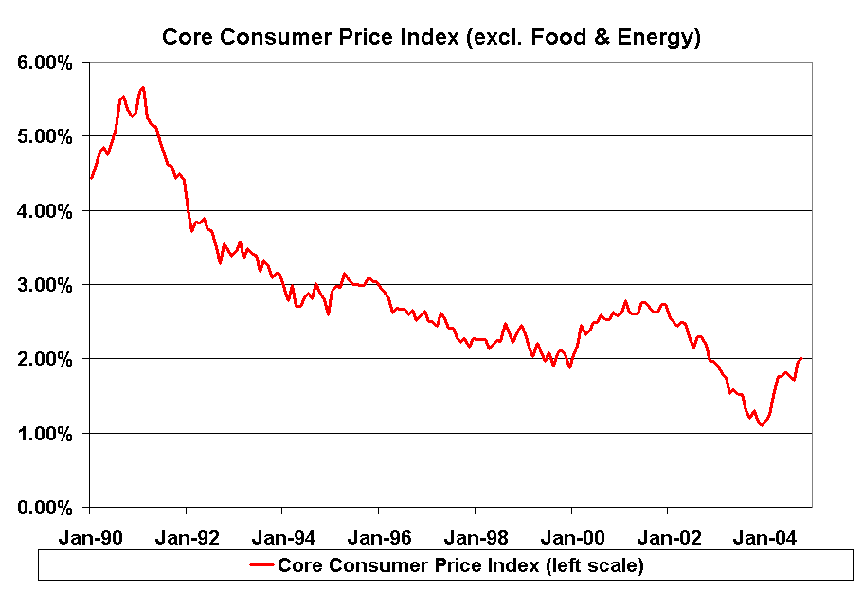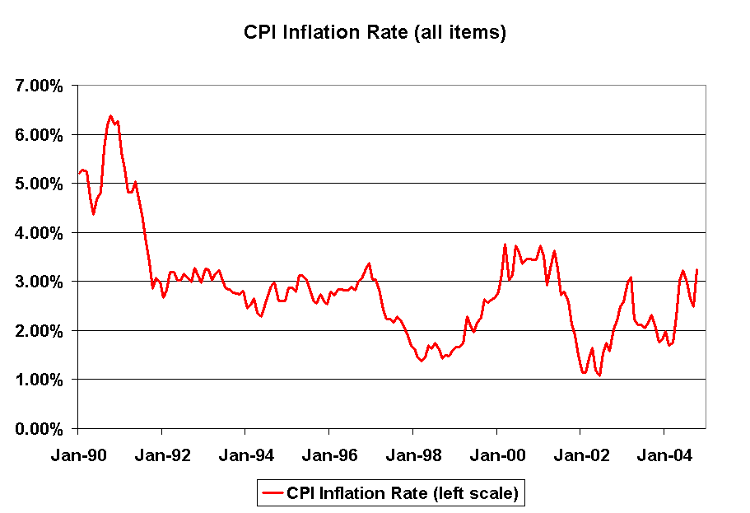

Inflation is the bond market's greatest nemesis and all indications are that the U.S. inflation rate is accelerating. This is quite clear from today's release on consumer prices and in Tuesday's release on producer prices.
In recent days, Federal Reserve officials have indicated that the Fed is likely to continue raising interest rates in the months ahead. The Federal Reserve's continued resolve against inflation is contributing to a steady flattening of the yield curve, with short-term interest rates up sharply since the Fed's first rate hike in June but long-term rates lower.
Tony Crescenzi wrote today: “The put/call ratios on the options for 10-year T-note futures reached a multiyear high over the past week, using the rolling 10- and 15-day averages as a gauge. Speculators began buying puts before the election and they continued to do so following the recent employment data, likely betting that the ending of uncertainties surrounding the election and renewed vigor in job hiring would weaken Treasuries. The extraordinary level of bearish options activity likely helped to prevent the logical response to these events, meaning Treasury Bonds did not go down and yield did not go up. The short-term nature of these option bets means this factor will exhaust itself in the coming weeks.”

All of these factors are important, but they lack a fundamental basis. They therefore seem unlikely to support any meaningful decline in yields from current levels. Accelerating inflation, increased competition for capital from rising stock prices, solid prospects for holiday spending and a continuation of recent improvements in the labor market are reasons to believe the rally T-Bonds won't last, unless Japan gobbles up significantly more Treasuries.

So there you have it. In the coming months, 10-year yields should rise, albeit slowly. Inflation is coming back and the Fed is aware of it.

Hermann Vohs

To learn more about our current recommendations call us toll free at: 866- 33-CALES (866-332-2537)

