Cales Investments, Inc.
Member NASD / Member SIPC

July 15, 2004

The Pause that refreshes

A major week for news produced minor losses for blue chips, with the Dow Jones Industrial Average falling 0.6% and the S&P 500 shedding 1%. Selling was heavier in the Nasdaq Composite, which gave up 3.2% over the five sessions. The week was frustrating for bulls and bears alike. Wild rallys in the morning were met with instant selling a couple of hours later. Many Companies that were beating earnings expectations but failed to promise double digit earnings growth in the coming quarters were punished severly. Intel’s earnings were in line, but margin pressure and rising inventories were enough to take the stock lower by some 13% on 4.5 times normal volume. The fact that Intel expected above average chip demand for the coming quarter did not seem to matter. The current environment has bulls and bears clinging to their opinions. Befitting a nation more politically polarized than at any time in a generation, there doesn't seem to be a lot of middle ground on Wall Street these days either -- people are either wildly bullish or apocalyptically bearish.
In my last Newsletter I tried to show how the economy was slowing down and how that would lead to lower interest rates over time. The slowdown did produce falling interest rates, yes. However investors were still not happy. They just substituted the old bogeyman (rising interest rates) with the new bogeyman (decelerating economy and a subdued profit outlook) and kept on the sidelines just the same.
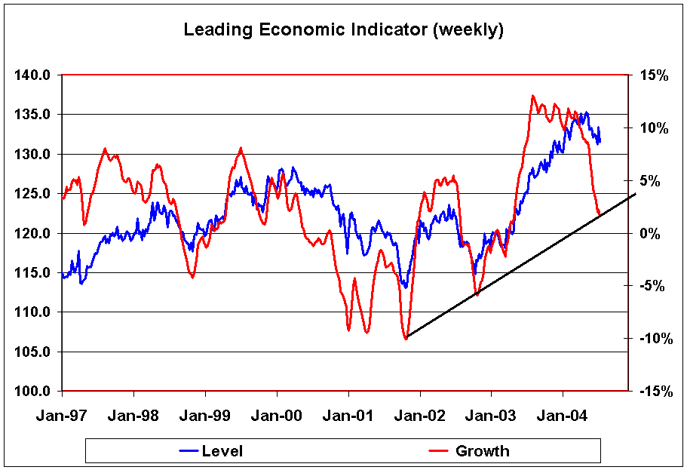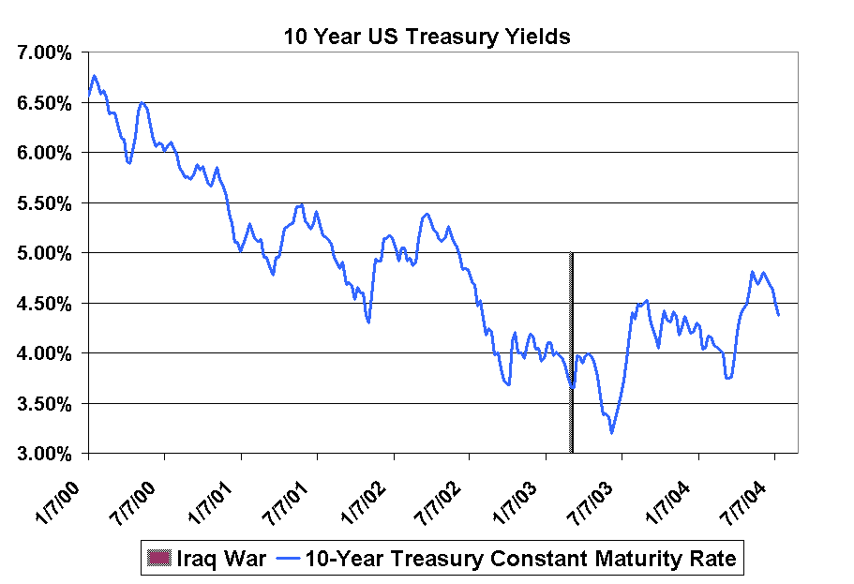

You can see that the growth rate of the Leading Economic Indicator has decelarated dramatically and exhibited a growth rate of only 1.3% for the week ended July 9th. This is the lowest growth since the week of April 25, 2003. Investors are now afraid that the economy is falling off a cliff.

Interest rates have fallen as predicted. Reduced economic activity gives the market confidence that Greenspan is not going to raise interest rates dramatically. Eurodollar Futures are pricing in 25 basis points for each of the next meetings. Some even speculate that the Fed might take more time.

Interest rates (the former bogeyman) seem to stabilize at a lower level, which is good for PE ratios. Indeed, stocks stack up well compared with bonds using the so-called Fed model mentioned by the central bank in the mid-1990s. That model compares the "earnings yield" on the S&P 500 based on projected profits in the next 12 months to the 10-year Treasury. (The earnings yield is the inverse of the S&P's P/E ratio.) Based on this admittedly simplistic model, the S&P is about 27% undervalued, assuming operating profits of $66 for 2004. If we take “as reported earnings” which Standard & Poors expects to come in at $58.86 the model still suggests an 18% undervaluation. The 10-year Treasury yield, now 4.37%, would have to hit 6% to make bonds as attractive as stocks. So what is wrong with the market? Is oil taking the wind out it? Is it geopolitical uncertainties? Do stock investors like Bush better than Kerry and anticipate that a Kerry government is going to reverse some tax cuts? It might be all of the above and the knowledge that interest rates will keep rising, albeit slowly. Lets not forget that 20% of all stocks in the S&P 500 are financial companies. They will definetely get hurt by rising interest rates.
The other complicating factor are earnings estimates themselves. The chart below depicts three different earnings measurements published by Standard & Poors.
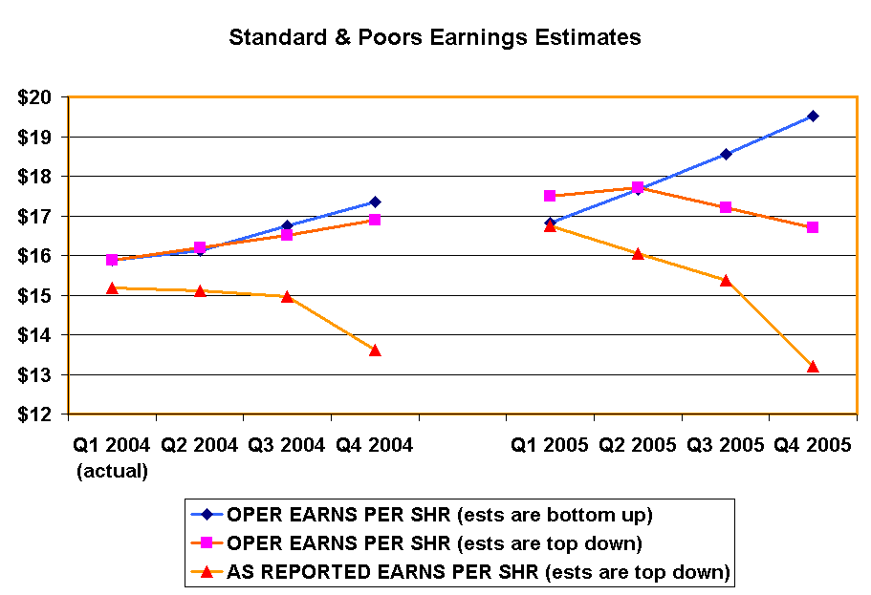
Operating Earnings per share: A measure of a company's earning power from ongoing operations, equal to earnings before deduction of interest payments and income taxes. also called operating profit or EBIT (earnings before interest and taxes). The “bottom up” estimates analyze each individual company and add up the resulting total earnings estimates. The “top-down” approach analyzes entire sectors and estimates cumulative earnings based on industry conditions.
“As Reported Earnings” per share: Earnings as reported by the company, which includes interest expense, income taxes, amortization, depreciation and one time items such as inventory write-downs.
*** Please note that the 2005 As Reported estimate includes option expense that is expected to become mandatory

The earnings estimates in the picture above show an extremely wide variance. The 2005 numbers for one and the same earnings yardstick (Operating Earnings) show a drastic divergence between “top-down” and “bottom-up” approaches. No wonder investors are confused. No wonder volume has dried up. Volume is strong when institutional investors make long term investment decisions with confidence. If they lack confidence, volume dries up. Volume signifies conviction. The lack of volume and conviction can be explained by the confused long term earnings outlook.
I suspect that the key for the future will be successful stock picking and sector allocation. Certain sectors will increase their contribution to earnings (manufacturing, energy), while other sectors (finance) will decrease their overall contribution. I any event, I continue to be bullish and expect the remainder of the year to be very rewarding.
Hermann Vohs

To learn more about our current recommendations call us toll free at: 866- 33-CALES (866-332-2537)

