Cales Investments, Inc.
Member NASD / Member SIPC

January 2, 2004
Trend reversals in 2004?

The NASDAQ Composite closed the year with a 50% gain, the S&P 500 recovered by 26% and the Dow Jones Industrials increased by 25%. The year 2003 belonged to the risk takers. Stocks with no earnings and half a business were the best performers this year. While the rising liquidity tide really lifted all boats, it was the dogs of the NASDAQ, half dead and kicked to the curb, which leaped by several hundred percent this past year. Risk premiums in bond and stock markets came down substantially in 2003. Contracting high yield (junk bond) spreads afforded companies the ability to refince their debt and to issue more stock to shore up their balance sheets. The other two asset classes that performed well were the precious metals, the precious metal stocks (the Phildalphia XAU Gold & Silver Index was up almost 42%) and raw materials of all kind. The dollar meanwhile lost another 15% this year.
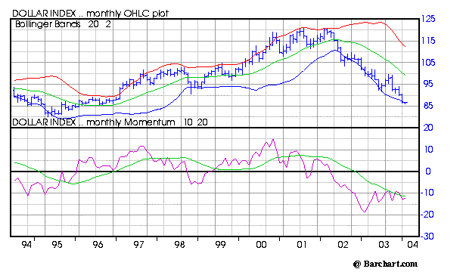
Recently, everybody is for some reason engaging in predictions and telling fortunes. It must be the season or something. I will neatly fit myself into this prodigious lot of stargazers and make some predictions of my own.

The major trends for 2004:
- The dollar will find support and due to better economic conditions, will attract investment interest once again. I believe that a dramtic reversal in the dollar will occur within the next three months. Whether this will be a temporary phenomenon or not remains to be seen since long term trends do not turn on a dime. Right now, every banker and individual investor in Europe and the U.S. seems to “know” that the dollar will continue to depreciate. After all, George Soros is short also. That is a little bit too much company for my taste. I will start betting the other way as soon as some incident causes the dollar to spike down.
- Gold will return to earth for a while. I believe that a short (6-9 months)and sharp bearmarket rally in the dollar will give gold investors the jitters and cause a short and sharp correction in the metal for half a year. This correction, should it come as expected, would be a glorios buying opportunity for long term investors.

- Oil will have wild gyrations in 2004. We are in a bull market, however. The hallmark of bull markets are short and sharp corrections. This year will see plenty of volatility. The middle east is destabilizing and the old cartels are losing control. World demand however is increasing rapidly and shocks will probably come from the supply side, not the demand side. Countries like Nigeria, Venezuela and Saudi Arabia might give us dramatic headlines this year.
- SEC investigations started to commence in earnest about 2 years ago. Companies like Worldcom and Enron as well as Bristol Myers, Qwest, El Paso and Dynegy were all served their first subpoenas 2 to 3 years ago. These investigations are being wrapped up and once the damage to a specific company becomes clear (due to a settlement or a judgement being handed down) the risk premiums in these companies evaporate. I expect dramatic performances from companies, that are able to announce publicly that a settlement has been reached with the SEC.
- Telecom will make a comeback as far fetched as it may sound. Price wars are still ravaging balance sheets and income statements, but valuations in many companies seem reasonable now. PE ratios in the 12 to 18 range are discounting no growth prospects whatsoever. I believe that the basing process in the telecom sector is complete and that an upturn in 2004 can be expected.

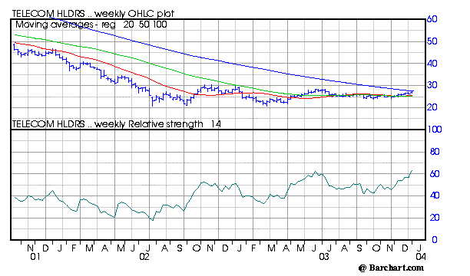
The chart above shows the Telecom HOLDRS Trust which trades under the ticker symbol TTH. (Telecom HOLDRS are Depositary Receipts issued by the Telecom HOLDRS Trust which represent an undivided beneficial ownership in the common stock of a group of 20 specified companies that are involved in various segments of the Telecommunications Industry.) The Relative Strength Index has surpassed the previous high which seems to indicate that the telecom industry is ready to break out of its 18 months base. Watch this sector carefully. We might have a winner here.

Finally I would like to thank all of our customers for their trust in us. I wish you all a prosperous new year.

Hermann Vohs

To learn more about our current recommendations call us toll free at: 866- 33-CALES (866-332-2537)

