Cales Investments, Inc.
Member NASD / Member SIPC
Sunday, August 31, 2003

A Tale of two Markets

“Sell in May and go away” goes the old saying. This year, however, that was not good advice for stock investors. Bond investors should have heeded this advice. The stock market, however, fooled everybody. While the S&P 500 stayed in a broad range between 960 and 1015, the NASDAQ was able to advance from 1,600 at the end of May to over 1800 at the end of August. Ample liquidity seems to have fueled the NASDAQ advance. Companies in this index are often more speculative stocks with neat concepts, lots of promise but little or no earnings. Liquidity fueled speculation in these companies. Meanwhile, corporations in the S&P 500 index had to bide their time, waiting for definite signs that the economy and thus their profit expectations would improve. It seems to me that this time has come now.

NASDAQ Composite Standard & Poors 500
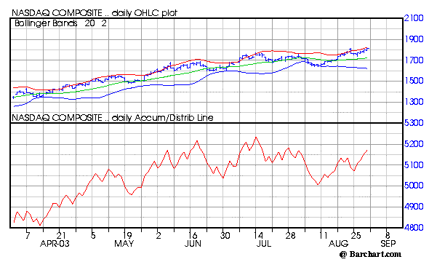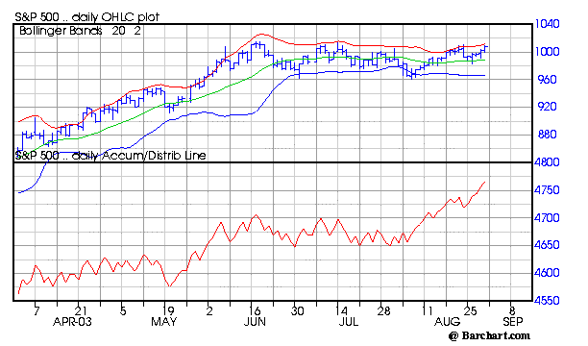

The red line below shows the Accumulation/Distribution Index, which in simple terms attempts to show, whether a stock or an Index is under accumulation or distribution. When the NASDAQ broke out to a new high in August, the red line did not reach a new high by a long shot. This is called a negative diversion and seems to indicate that the NASDAQ might not advance very much from here. Now look at the S&P 500 index. The red line has clearly broken out to a new high while the Index is still well within its trading range. I believe that this Index is poised to break out this week. The reason might be that investors think that they finally can see the white in the eyes of the heretofore elusive recovery. Industrial production had its biggest jump in 6 months, consumer confidence rebounded above expectations and corporate profitability is continuing to rise. What is missing are improving unemployment numbers. So far, market participants could found solice in the declining numbers of initial claims for unemployment benefits, which stayed below the important benchmark of 400,000 for three straight weeks. This Friday should bring more clarity, whether the unemployment rate finally dips below 6%. Should that be the case, the Standard & Poors 500 could very well make another 5% to 10% run. The other factor that contained the advance of big U.S. corporations in the past 3 months was the fact that capital spending was stagnant and did not seem to improve enough to create a self sustaining recovery. This seems to change for the better also. While it is true that many corporations suffer from to much indebtedness, which forces them to curtail further investments, it is also true that (still) low interest rates and a narrowing interest differential between corporate bonds and treasury bonds have enabled many companies to deleverage their balance sheets significantly. In other words, capital spending should pick up in the coming months. The chart below shows a crucial relationship between corporate profits and capital spending.

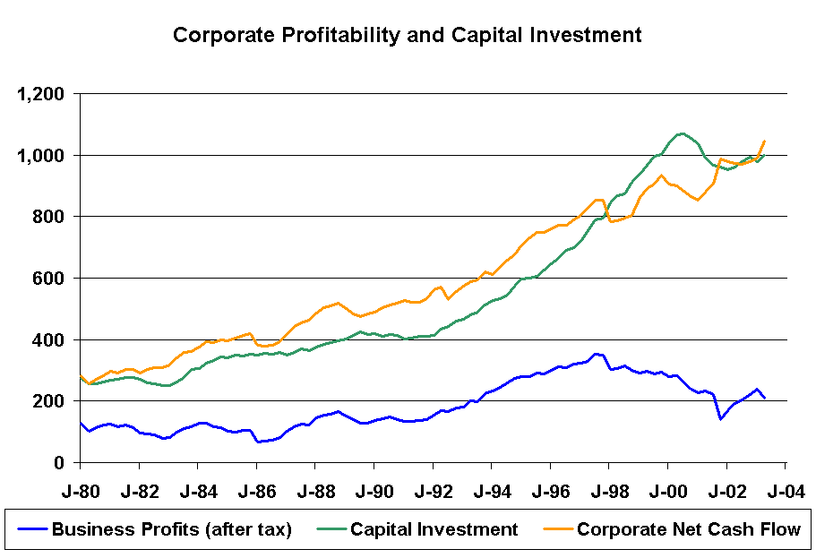

You can see that between 1980 and October 1997 Corporate Net Cash Flow (cash receipts minus cash outlays) always grew ahead of capital investments. This relationship changed after October 1997, when capital investments grew faster than corporate net cash flow. This created the speculative overbuild in the economy, which resulted in to much capacity chasing to few buyers. Since the first quarter of 2003, however, the old relationship seems to have been re-established. Corporate net cash flow is leading capital investment again. Unfortunatly, the latest data available is for the first quarter of this year. New data for the second quarter will become available in two weeks. Should the current trajectory of net cash flow and capital investment continue, the market and especially the old economy stocks could have another good run. The caveat as always is, that profits and valuations do matter for every company. The one factor that could spoil the party are interest rates. Should interest rates rise significantly from here, all bets are off. Even though, the stock market is fundamentally in better shape than at any time during the last 3 years.

Hermann Vohs

To learn more about our current recommendations call us toll free at: 866- 33-CALES (866-332-2537)

